**Login page**

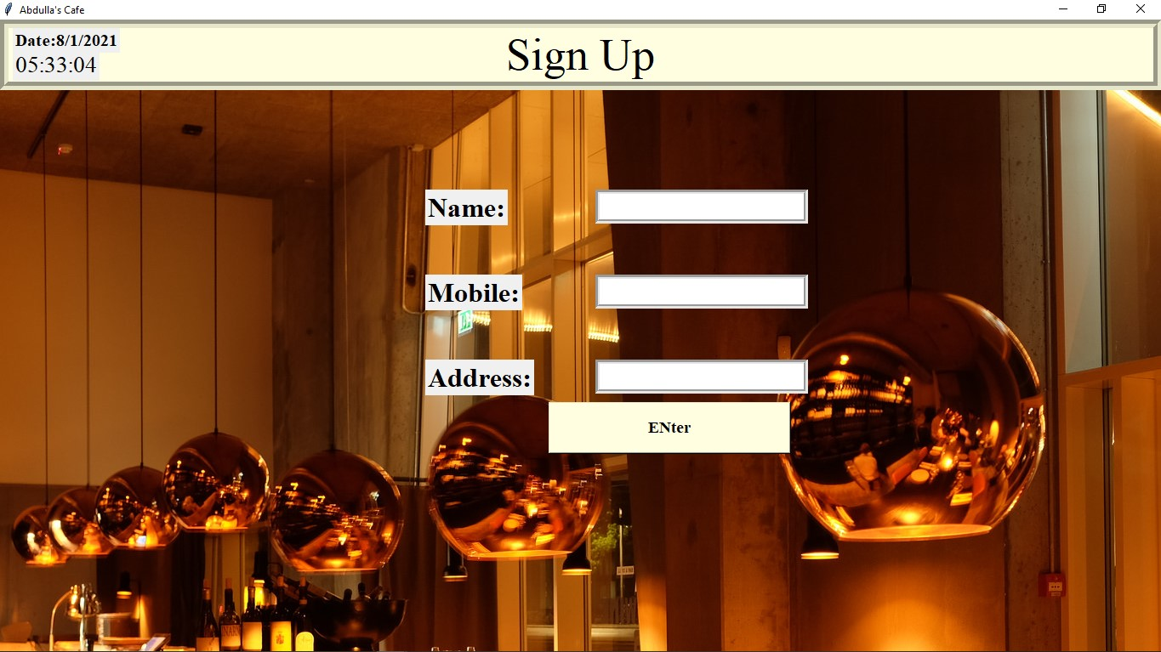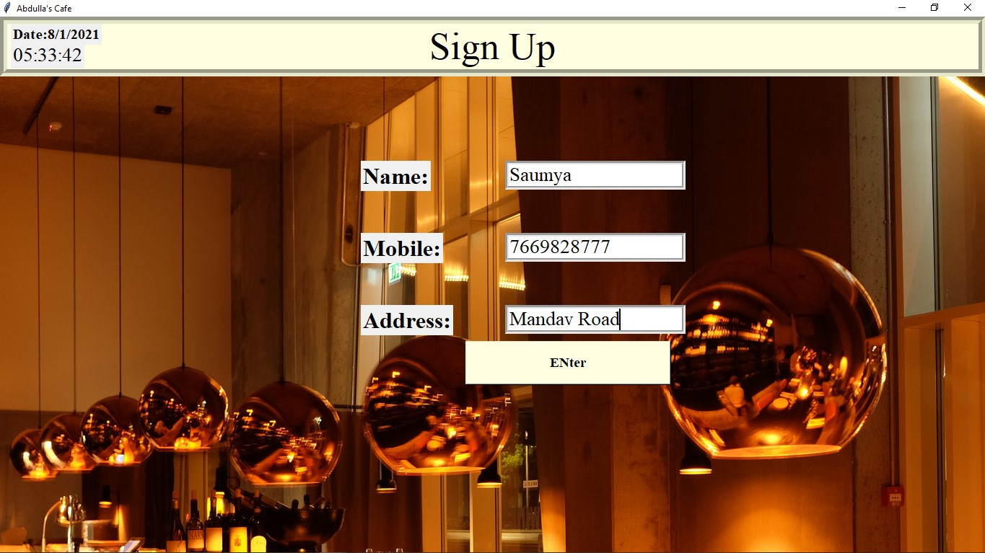

Login page (Coding)

from tkinter import *

import os

from PIL import ImageTk

from tkinter import messagebox

import time

import csv

class Login_System:

def __init__(self,root):

self.root=root

self.root.title("spring food court")

self.root.geometry("1920x1080+0+0")

self.img=ImageTk.PhotoImage(file="7.jpg")

self.img_Label=Label(image=self.img,bd=0)

self.img_Label.place(x=00,y=00)

title=Label(text="Sign Up",font=("Times new roman",40,),bd=10,relief=GROOVE,bg="light yellow")

title.place(x=0,y=0,relwidth=1)

lbl_user=Label(text="Name:",font=("Times new roman",24,"bold"))

lbl_user.place(x=500,y=200)

self.txt_user=Entry(font=("times new roman",20),bg="white",bd=5,relief=GROOVE)

self.txt_user.place(x=700,y=200,width=250,height=40)

lbl_mobile=Label(text="Mobile:",font=("Times new roman",24,"bold"))

lbl_mobile.place(x=500,y=300)

self.txt_mobile=Entry(font=("times new roman",20),bg="white",bd=5,relief=GROOVE)

self.txt_mobile.place(x=700,y=300,width=250,height=40)

lbl_add=Label(text="Address:",font=("Times new roman",24,"bold"))

lbl_add.place(x=500,y=400)

self.txt_add=Entry(font=("times new roman",20),bg="white",bd=5,relief=GROOVE)

self.txt_add.place(x=700,y=400,width=250,height=40)

#==========================================Button==================#

Login_btn_emp=Button(self.root,command=self.login_function,text="ENter",width=25,height=2,font=("Times new roman",14,"bold"),fg="black",bg="Light yellow")

Login_btn_emp.place(x=645,y=450)

#=========================================Clock&Date=============#

def clock():

hour=time.strftime("%I")

minute=time.strftime("%M")

second=time.strftime("%S")

clock_lable.config(text=hour + ':' + minute + ':' + second)

clock_lable.after(1000,clock)

clock_lable=Label(root, text="", font=("Times new roman",20))

clock_lable.place(x=15,y=35)

clock()

Date_lable=Label(root,text="Date:8/1/2021",font=("Times new roman",15,"bold"))

Date_lable.place(x=15,y=10)

#============================Buttonfunction==========================

def login_function(self):

if self.txt_user.get()=="" or self.txt_mobile.get()=="" or self.txt_add.get()=="":

messagebox.showerror("Error","All fields are required",parent=self.root)

else:

os.system("1.py")

cv_1= self.txt_user.get()

cv_2=self.txt_mobile.get()

cv_3=self.txt_add.get()

with open("user.csv",mode="a") as f:

w=csv.writer(f,delimiter=',',quotechar='"',quoting=csv.QUOTE_ALL)

w.writerow([cv_1,cv_2,cv_3])

root=Tk()

obj=Login_System(root)

root.mainloop()

Hotel Selection

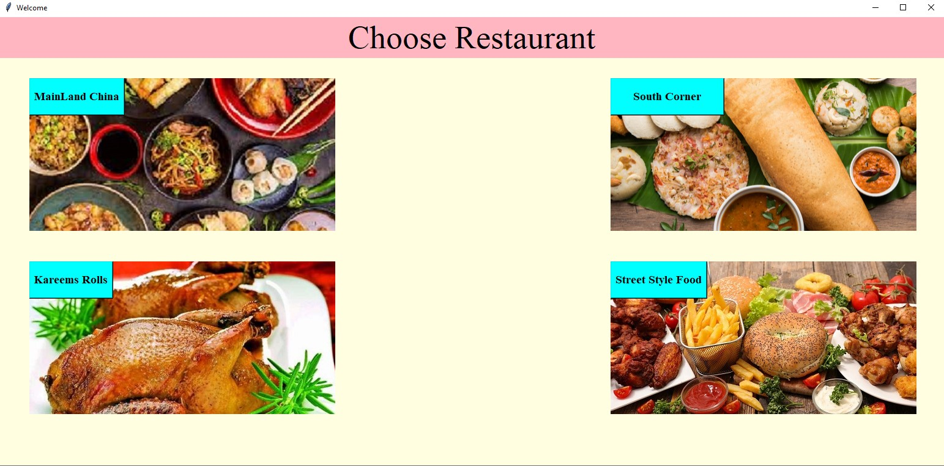

Hotel Selection(coding)

from tkinter import*

import os

from PIL import ImageTk

from tkinter import messagebox

root=Tk()

root.title("Welcome")

root.configure(background="light Yellow")

title=Label(text="Choose Restaurant",font=("Times new roman",40,),fg="black",bg="light pink")

title.place(x=0,y=0,relwidth=1)

def indian():

os.system("south.py")

def indian1():

os.system("chinese.py")

def indian2():

os.system("nonveg.py")

def indian3():

os.system("street.py")

my_img=ImageTk.PhotoImage(file="12.jpg")

my_label=Label(image=my_img)

my_label.place(x=1000,y=100,height="250",width="500")

a=Button(root,command=indian,text="South Corner",height=2,width=16, font=("Times new roman",14,"bold"),fg="black",bg="cyan")

a.place(x=1000,y=100)

my_i=ImageTk.PhotoImage(file="chinese.jfif")

my_labl=Label(image=my_i)

my_labl.place(x=50,y=100,height="250",width="500")

a1=Button(root,command=indian1,text="MainLand China",height=2,font=("Times new roman",14,"bold"),fg="black",bg="cyan")

a1.place (x=50,y=100)

my1=ImageTk.PhotoImage(file="nv1.jpg")

my_=Label(image=my1)

my_.place(x=50,y=400,height="250",width="500")

a2=Button(root,command=indian2,text="Kareems Rolls",height=2,font=("Times new roman",14,"bold"),fg="black",bg="cyan")

a2.place(x=50,y=400)

my=ImageTk.PhotoImage(file="ff.jpg")

my_=Label(image=my)

my_.place(x=1000,y=400,height="250",width="500")

a3=Button(root,command=indian3,text="Street Style Food",height=2,font=("Times new roman",14,"bold"),fg="black",bg="cyan")

a3.place(x=1000,y=400)

root.geometry("1920x1080+0+0")

root.mainloop()

Main Land China

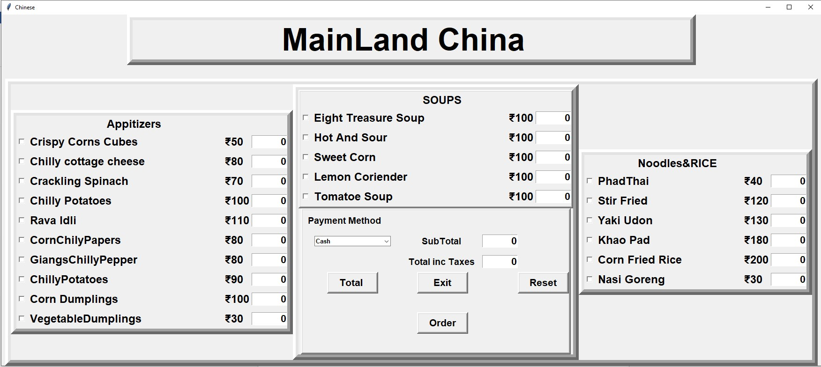

Main Land China(coding)

from tkinter import*

import random

import time;

import datetime

import csv

from tkinter import Tk, StringVar, ttk,messagebox

root=Tk()

root.geometry("1750x750+0+0")

root.title("Chinese")

Tops=Frame(root,width=1550,height=100,bd=12,relief="raise")

Tops.pack(side=TOP)

lblTitle=Label(Tops,font=("ariel",50,"bold"),text="\t MainLand China\t\t")

lblTitle.grid(row=0 , column=0)

btmmainframe=Frame(root,width=1350,height=650,bd=12,relief="raise")

btmmainframe.pack(side=BOTTOM)

f1=Frame(btmmainframe,width=450,height=650,bd=12,relief="raise")

f1.pack(side=LEFT)

f2=Frame(btmmainframe,width=450,height=450,bd=12,relief="raise")

f2.pack(side=LEFT)

f2top=Frame(f2,width=450,height=300,bd=4,relief="raise")

f2top.pack(side=TOP)

f2btm=Frame(f2,width=450,height=300,bd=4,relief="raise")

f2btm.pack(side=BOTTOM)

f3top=Frame(btmmainframe,width=450,height=300,bd=12,relief="raise")

f3top.pack(side=RIGHT)

x1=IntVar()

x2=IntVar()

x3=IntVar()

x4=IntVar()

x5=IntVar()

x6=IntVar()

x7=IntVar()

x8=IntVar()

x9=IntVar()

x10=IntVar()

x11=IntVar()

x12=IntVar()

x13=IntVar()

x14=IntVar()

x15=IntVar()

x16=IntVar()

x17=IntVar()

x18=IntVar()

x19=IntVar()

x20=IntVar()

x21=IntVar()

x22=IntVar()

x23=IntVar()

x1.set(0)

x2.set(0)

x3.set(0)

x4.set(0)

x5.set(0)

x6.set(0)

x7.set(0)

x8.set(0)

x9.set(0)

x10.set(0)

x11.set(0)

x12.set(0)

x13.set(0)

x14.set(0)

x15.set(0)

x16.set(0)

x17.set(0)

x18.set(0)

x19.set(0)

x20.set(0)

x21.set(0)

x22.set(0)

x23.set(0)

xGrilledidlis=StringVar()

xMasalaIdli=StringVar()

xRavaMasalaIdli=StringVar()

xSoojiMasalaIdli=StringVar()

xRavaIdli=StringVar()

xSojiIdli=StringVar()

xfriedidli=StringVar()

xravaidlifried=StringVar()

xsoojiFriedidli=StringVar()

xplaneidli=StringVar()

xRavaMasalaDosa=StringVar()

xMasalaDosa=StringVar()

xPlainDosa=StringVar()

xRavaDosa=StringVar()

xSoojiMasalaDosa=StringVar()

xmoj=StringVar()

xlir=StringVar()

xspt=StringVar()

xbm=StringVar()

xcok=StringVar()

xfan=StringVar()

xChange=StringVar()

x22=StringVar()

xSubTotal=StringVar()

xTax=StringVar()

xTotal=StringVar()

xGrilledidlis.set("0")

xMasalaIdli.set("0")

xRavaMasalaIdli.set("0")

xSoojiMasalaIdli.set("0")

xRavaIdli.set("0")

xSojiIdli.set("0")

xfriedidli.set("0")

xravaidlifried.set("0")

xsoojiFriedidli.set("0")

xplaneidli.set("0")

xRavaMasalaDosa.set("0")

xMasalaDosa.set("0")

xPlainDosa.set("0")

xRavaDosa.set("0")

xSoojiMasalaDosa.set("0")

xmoj.set("0")

xlir.set("0")

xspt.set("0")

xbm.set("0")

xcok.set("0")

xfan.set("0")

xChange.set("0")

x22.set("0")

x23.set("0")

xSubTotal.set("0")

xTax.set("0")

xTotal.set("0")

#=====================================frame1=======================#

lblTitle=Label(f1,font=("ariel",18,"bold"),text="Appitizers")

lblTitle.grid(row=0 , column=0)

Grilledidlis=Checkbutton(f1,text="CrispyCornsCubes\t\t₹50",variable=x1,onvalue=1,offvalue=0,font=("ariel",18,"bold")).grid(row=1,column=0,sticky=W)

txtGrilledidlis=Entry(f1,font=('arial',16,'bold'),textvariable=xGrilledidlis,width=6,justify='right').grid(row=1,column=1)

MasalaIdli=Checkbutton(f1,text="Chillycottagecheese\t\t₹80",variable=x2,onvalue=1,offvalue=0,font=("ariel",18,"bold")).grid(row=2,column=0,sticky=W)

txtMasalaIdli=Entry(f1,font=('arial',16,'bold'),textvariable=xMasalaIdli,width=6,justify='right').grid(row=2,column=1)

RavaMasalaIdli=Checkbutton(f1,text="CracklingSpinach\t\t₹70",variable=x3,onvalue=1,offvalue=0,font=("ariel",18,"bold")).grid(row=3,column=0,sticky=W)

txtRavaMasalaIdli=Entry(f1,font=('arial',16,'bold'),textvariable=xRavaMasalaIdli,width=6,justify='right').grid(row=3,column=1)

SoojiMasalaIdli=Checkbutton(f1,text="ChillyPotatoes\t\t\t₹100",variable=x4,onvalue=1,offvalue=0,font=("ariel",18,"bold")).grid(row=4,column=0,sticky=W)

txtSoojiMasalaIdli=Entry(f1,font=('arial',16,'bold'),textvariable=xSoojiMasalaIdli,width=6,justify='right').grid(row=4,column=1)

RavaIdli=Checkbutton(f1,text="RavaIdli\t\t\t\t₹110",variable=x5,onvalue=1,offvalue=0,font=("ariel",18,"bold")).grid(row=5,column=0,sticky=W)

txtRavaIdli=Entry(f1,font=('arial',16,'bold'),textvariable=xRavaIdli,width=6,justify='right').grid(row=5,column=1)

SojiIdli=Checkbutton(f1,text="CornChilyPapers\t\t\t₹80",variable=x6,onvalue=1,offvalue=0, font=("ariel",18,"bold")).grid(row=6,column=0,sticky=W)

txtSojiIdli=Entry(f1,font=('arial',16,'bold'),textvariable=xSojiIdli,width=6,justify='right').grid(row=6,column=1)

friedidli=Checkbutton(f1,text="GiangsChillyPepper\t\t₹80",variable=x7,onvalue=1,offvalue=0, font=("ariel",18,"bold")).grid(row=8,column=0,sticky=W)

txtfriedidli=Entry(f1,font=('arial',16,'bold'),textvariable=xfriedidli,width=6,justify='right').grid(row=8,column=1)

ravaidlifried=Checkbutton(f1,text="ChillyPotatoes\t\t\t₹90",variable=x8,onvalue=1,offvalue=0,font=("ariel",18,"bold")).grid(row=9,column=0,sticky=W)

txtravaidlifried=Entry(f1,font=('arial',16,'bold'),textvariable=xravaidlifried,width=6,justify='right').grid(row=9,column=1)

soojiFriedidli=Checkbutton(f1,text="CornDumplings\t\t\t₹100",variable=x9,onvalue=1,offvalue=0,font=("ariel",18,"bold")).grid(row=10,column=0,sticky=W)

txtsoojiFriedidli=Entry(f1,font=('arial',16,'bold'),textvariable=xsoojiFriedidli,width=6,justify='right').grid(row=10,column=1)

planeidli=Checkbutton(f1,text="VegetableDumplings\t\t₹30",variable=x11,onvalue=1,offvalue=0, font=("ariel",18,"bold")).grid(row=12,column=0,sticky=W)

Entry(f1,font=('arial',16,'bold'),textvariable=xplaneidli,width=6,justify='right').grid(row=12,column=1)

#=====================================frame2=====================#

lbldess=Label(f2top,font=("ariel",18,"bold"),text="\tSOUPS")

lbldess.grid(row=0 , column=0)

PlainDosa=Checkbutton(f2top,text="EightTreasureSoup\t\t₹100",variable=x12,onvalue=1,offvalue=0,font=("ariel",18,"bold")).grid(row=1,column=0,sticky=W)

txtPlainDosa=Entry(f2top,font=('arial',16,'bold'),textvariable=xPlainDosa,width=6,justify='right').grid(row=1,column=1)

MasalaDosa=Checkbutton(f2top,text="HotAndSour\t\t\t₹100",variable=x13,onvalue=1,offvalue=0,font=("ariel",18,"bold")).grid(row=2,column=0,sticky=W)

txtMasalaDosa=Entry(f2top,font=('arial',16,'bold'),textvariable=xMasalaDosa,width=6,justify='right').grid(row=2,column=1)

RavaDosa=Checkbutton(f2top,text="SweetCorn\t\t\t₹100",variable=x14,onvalue=1,offvalue=0,font=("ariel",18,"bold")).grid(row=3,column=0,sticky=W)

txtRavaDosa=Entry(f2top,font=('arial',16,'bold'),textvariable=xRavaDosa,width=6,justify='right').grid(row=3,column=1)

RavaMasalaDosa=Checkbutton(f2top,text="LemonCoriender\t\t\t₹100",variable=x15,onvalue=1,offvalue=0,font=("ariel",18,"bold")).grid(row=4,column=0,sticky=W)

txtRavaMasalaDosa=Entry(f2top,font=('arial',16,'bold'),textvariable=xRavaMasalaDosa,width=6,justify='right').grid(row=4,column=1)

SoojiMasalaDosa=Checkbutton(f2top,text="TomatoeSoup\t\t\t₹100",variable=x16,onvalue=1,offvalue=0,font=("ariel",18,"bold")).grid(row=5,column=0,sticky=W)

txtSoojiMasalaDosa=Entry(f2top,font=('arial',16,'bold'),textvariable=xSoojiMasalaDosa,width=6,justify='right').grid(row=5,column=1)

#=====================================frame3=======================#

lbldess=Label(f3top,font=("ariel",18,"bold"),text="Noodles&RICE")

lbldess.grid(row=0 , column=0)

cok=Checkbutton(f3top,text="PhadThai\t\t₹40",variable=x17,onvalue=1,offvalue=0font=("ariel",18,"bold")).grid(row=1,column=0,sticky=W)

txtcok=Entry(f3top,font=('arial',16,'bold'),textvariable=xcok,width=6,justify='right').grid(row=1,column=1)

moj=Checkbutton(f3top,text="StirFried\t\t₹120",variable=x18,onvalue=1,offvalue=0,font=("ariel",18,"bold")).grid(row=2,column=0,sticky=W)

txtmoj=Entry(f3top,font=('arial',16,'bold'),textvariable=xmoj,width=6,justify='right').grid(row=2,column=1)

bm=Checkbutton(f3top,text="YakiUdon\t\t₹130",variable=x19,onvalue=1,offvalue=0,font=("ariel",18,"bold")).grid(row=3,column=0,sticky=W)

txtbm=Entry(f3top,font=('arial',16,'bold'),textvariable=xbm,width=6,justify='right').grid(row=3,column=1)

spt=Checkbutton(f3top,text="KhaoPad\t\t₹180",variable=x20,onvalue=1,offvalue=

,font=("ariel",18,"bold")).grid(row=4,column=0,sticky=W)

txtspt=Entry(f3top,font=('arial',16,'bold'),textvariable=xspt,width=6,justify='right').grid(row=4,column=1)

lir=Checkbutton(f3top,text="CornFriedRice\t\t₹200",variable=x21,onvalue=1,offvalue=0,font=("ariel",18,"bold")).grid(row=5,column=0,sticky=W)

txtlir=Entry(f3top,font=('arial',16,'bold'),textvariable=xlir,width=6,justify='right').grid(row=5,column=1)

fan=Checkbutton(f3top,text="Nasi Goreng\t\t₹30",variable=x22,onvalue=1,offvalue=0,font=("ariel",18,"bold")).grid(row=6,column=0,sticky=W)

txtfan=Entry(f3top,font=('arial',16,'bold'),textvariable=xfan,width=6,justify='right').grid(row=6,column=1)

#=====================================FrameButton===============#

lb1PaymentMethod = Label(f2btm , font=('arial',14, 'bold'), text="Payment Method", bd=10, width= 16, anchor='w')

lb1PaymentMethod.grid(row=0,column=0)

cmbPaymentMethod = ttk.Combobox(f2btm , textvariable = x23, state='readonly', font=('arial',10, 'bold'), width= 20)

cmbPaymentMethod['value']=('Cash','Master Card','Visa Card','Debit Card'

cmbPaymentMethod.current(0)

cmbPaymentMethod.grid(row=1,column=0)

lb1SubTotal = Label(f2btm , font=('arial',14, 'bold'),text="SubTotal ", bd=10, anchor='w').grid(row=1 , column=1)

txtSubTotal = Entry(f2btm,font=('arial',16,'bold'),textvariable=xSubTotal,width=6,justify='right').grid(row=1,column=2)

lb1Total = Label(f2btm , font=('arial',14, 'bold'),text="Total inc Taxes ", bd=10, anchor='w').grid(row =3 , column =1)

txtTotal=Entry(f2btm,font=('arial',16,'bold'),textvariable=xTotal,width=6,justify='right').grid(row=3,column=2)

#=====================================FrameButton=================#

def order():

if messagebox.showinfo("South Corner","Thank you for ordering " ):

root.destroy()

def exit():

if messagebox.askyesno("South Corner","ARE u sure u want to exit " )== True:

root.destroy()

else:

return()

def Reset ():

xGrilledidlis.set("0")

xMasalaIdli.set("0")

xRavaMasalaIdli.set("0")

xSoojiMasalaIdli.set("0")

xRavaIdli.set("0")

xSojiIdli.set("0")

xfriedidli.set("0")

xravaidlifried.set("0")

xsoojiFriedidli.set("0")

xplaneidli.set("0")

xRavaMasalaDosa.set("0")

xMasalaDosa.set("0")

xPlainDosa.set("0")

xRavaDosa.set("0")

xSoojiMasalaDosa.set("0")

xmoj.set("0")

xlir.set("0")

xspt.set("0")

xbm.set("0")

xcok.set("0")

xfan.set("0")

xChange.set("0")

xSubTotal.set("0")

xTotal.set("0")

def costofmeal():

meal1 = float(xGrilledidlis.get())

meal2 = float(xMasalaIdli.get())

meal3 = float(xRavaMasalaIdli.get())

meal4 = float(xSoojiMasalaIdli.get())

meal5 = float(xRavaIdli.get())

meal6 = float(xSojiIdli.get())

meal7 = float(xfriedidli.get())

meal8 = float(xravaidlifried.get())

meal9 = float(xsoojiFriedidli.get())

meal10 = float(xplaneidli.get())

meal11 = float(xRavaMasalaDosa.get())

meal12 = float(xMasalaDosa.get())

meal13 = float(xPlainDosa.get())

meal14 = float(xRavaDosa.get())

meal15 = float(xSoojiMasalaDosa.get())

meal16 = float(xmoj.get())

meal17 = float(xlir.get())

meal18 = float(xspt.get())

meal19 = float(xbm.get())

meal20 = float(xcok.get())

meal21 = float(xfan.get())

iTotal1 =((meal1 * 50)+ (meal2 * 80) +(meal3 * 70) +(meal4 * 100))

iTotal2 =((meal5 * 110)+ (meal6 * 80) +(meal7 * 80) +(meal8 * 90))

iTotal3 =((meal9 * 100)+ (meal10 * 30) +(meal11 * 100) +(meal12 * 100))

iTotal4 =((meal13 * 100)+ (meal14 * 100) +(meal15 * 100) +(meal16 * 120))

iTotal5 =((meal17 * 200)+ (meal18 * 180) +(meal19 * 130) +(meal20 * 40))

iTotal6 =((meal21 * 30))

iCost = (iTotal1 + iTotal2 + iTotal3 + iTotal4 + iTotal5 + iTotal6)

iTax = (iCost * 2.8)/100

xSubTotal.set(iCost)

xTotal.set(iCost + iTax)

cv_1=xTotal.get()

cv_2=xSubTotal.get()

with open("chinabill.csv",mode="a") as f:

w=csv.writer(f,delimiter=',',quotechar='"',quoting=csv.QUOTE_ALL)

w.writerow([cv_1,cv_2])

btnTotal=Button(f2btm,padx=16,pady=1, bd=4, fg="black",font=('arial', 16,'bold'), width=5, text="Total ",command= costofmeal).grid(row=4, column=0)

btnReset=Button(f2btm,padx=16,pady=1, bd=4, fg="black",font=('arial', 16,'bold'), width=5, text="Reset",command= Reset).grid(row=4, column=3)

btnExit=Button(f2btm,padx=16,pady=1, bd=4, fg="black",font=('arial', 16,'bold'), width=5, text="Exit",command=exit).grid(row=4, column=1)

btnorder=Button(f2btm,padx=16,pady=1, bd=4, fg="black",font=('arial', 16,'bold'), width=5, text="Order",command=order).grid(row=5, column=1)

lblspace=Label( f2btm, text="\n\n\n\n\n\n\n")

lblspace.grid(row =5, column=0)

root.mainloop()

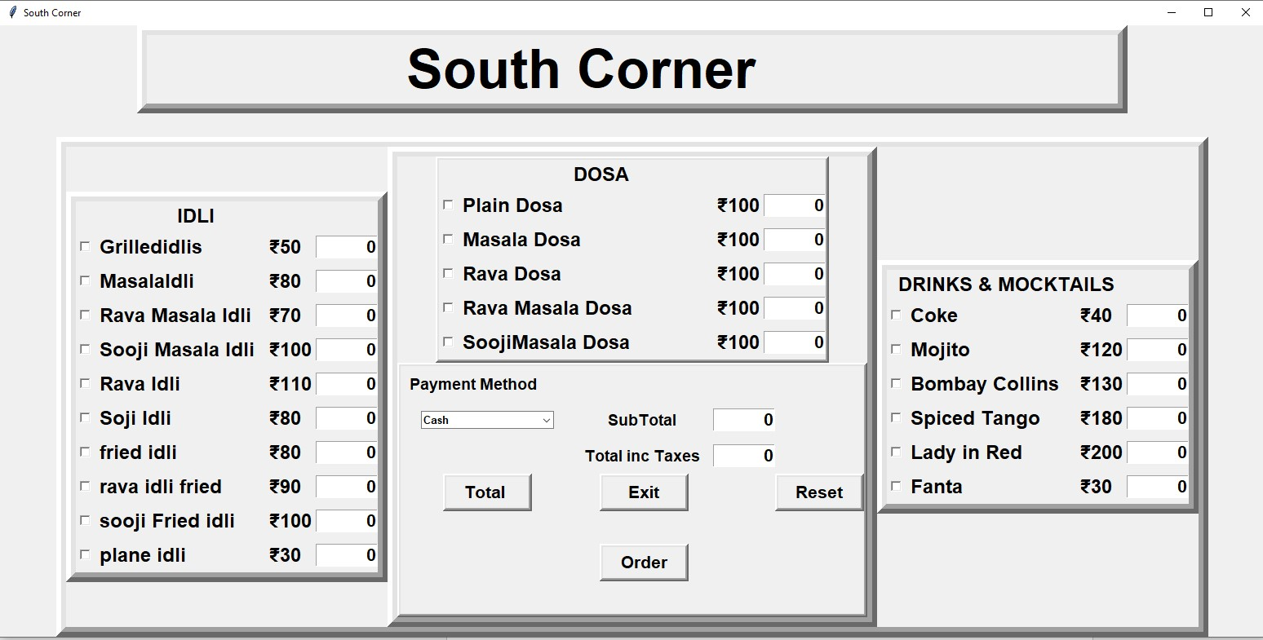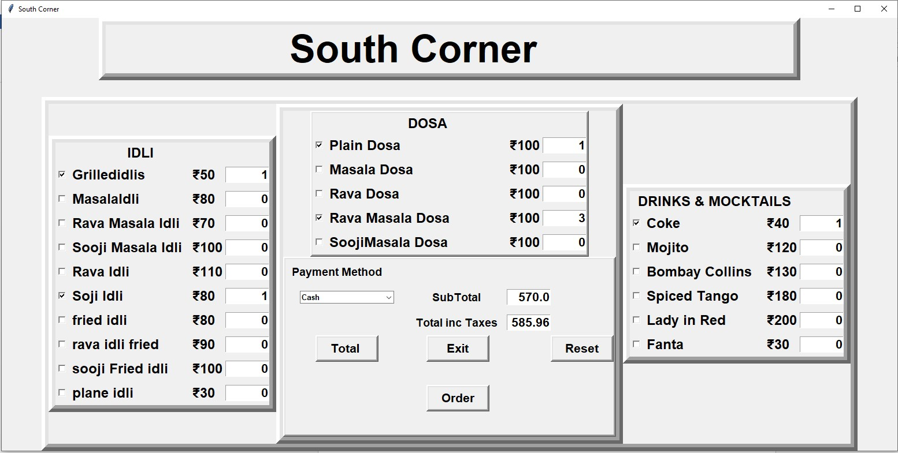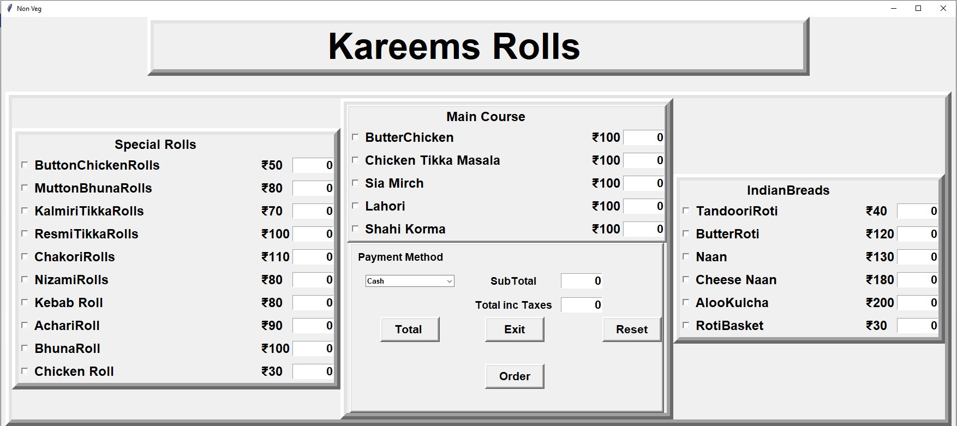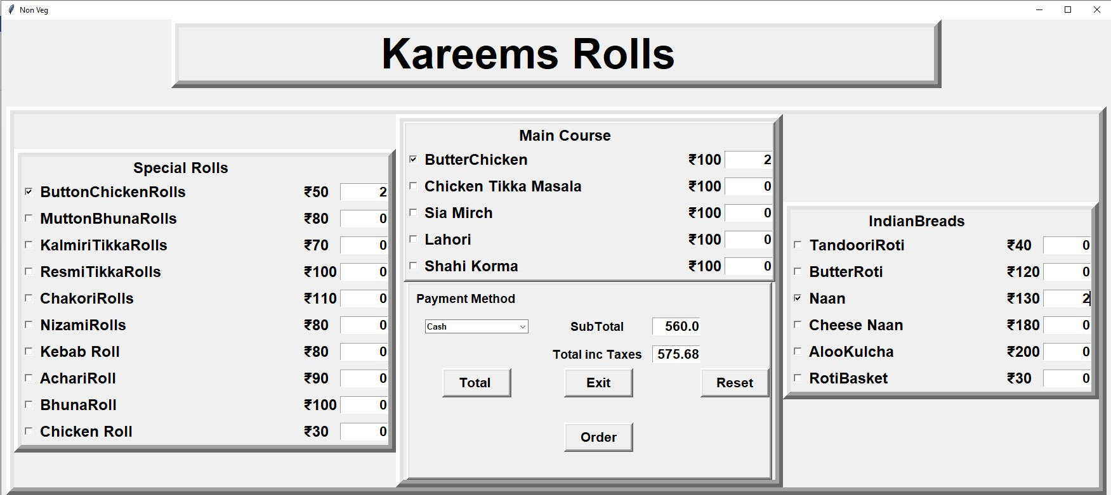

Street style food

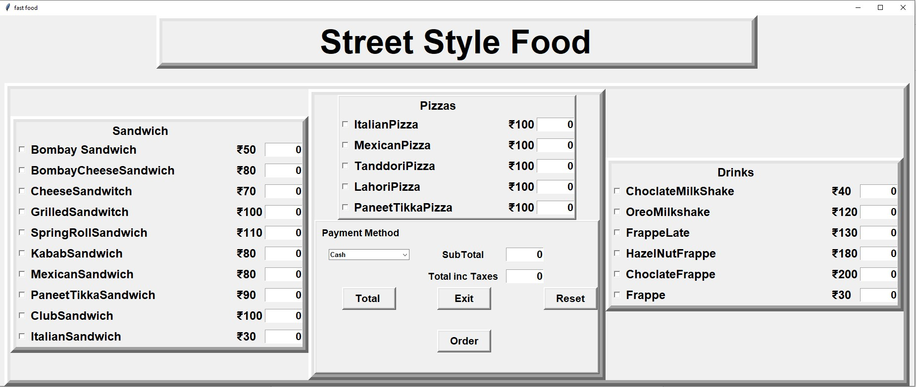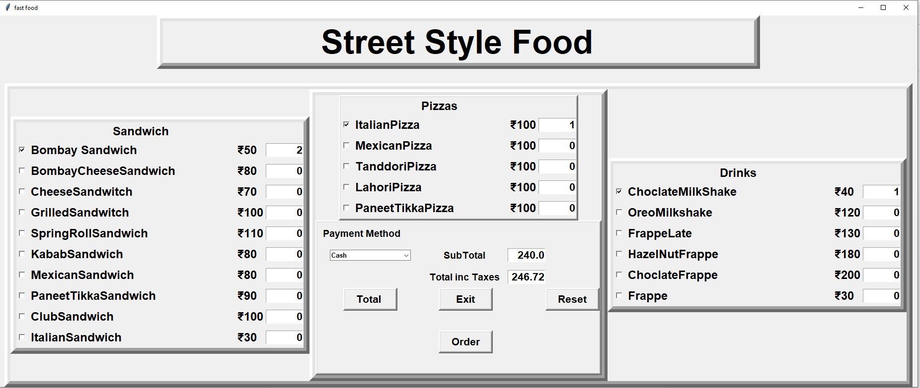

Reference : w3 School.com

Limitations : 1.Only cash payment is available

2. All restaurant file contains same defined variables, all restaurants has the same price.